**Pumps for water & sewage applications**

**WATER & SEWAGE RANGE**

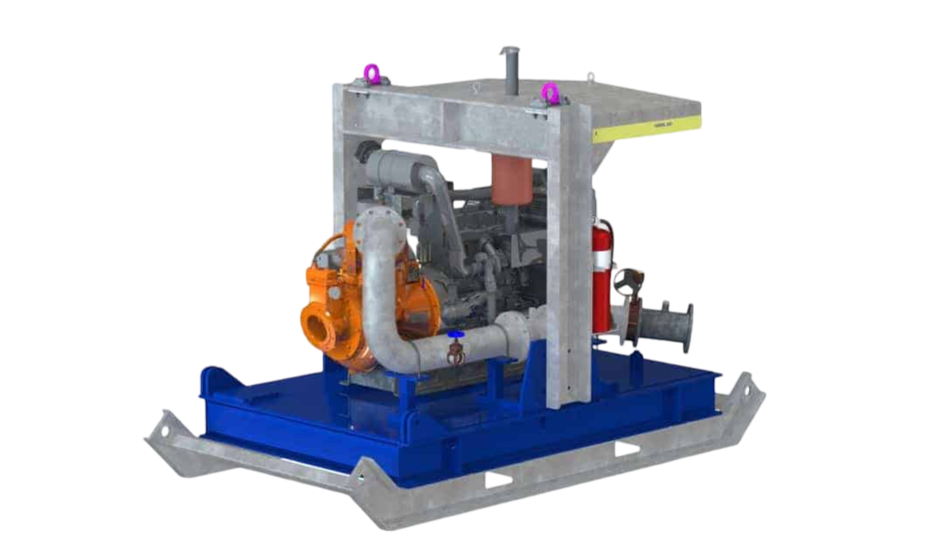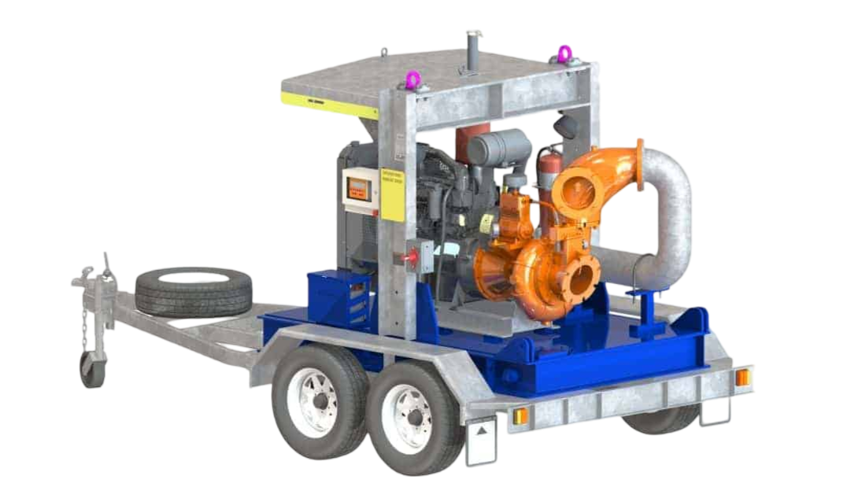

The Water & Sewage Range is specifically designed for sewage and waste water applications.

With an innovative design, these units are capable of pumping large solids of up to 110mm [4.3 inch].

These pumps chop and shred debris and other stringy materials that would normally cause clogging. All pumps are available with either compressor, vacuum, or diaphragm priming systems.

**Delivery & heads**

* Models range from 4 inch to 12 inch connections
* Covering suction lift up to 9 m
* Covering head up to 60 m
* Covering flow up to 470 L/sec

**AT A GLANCE**

* Heavy duty, robust design
* Large solids handling
* Cutter pockets
* Inspection cover
* Non-clog impeller
* Shredder claw
* Available in Standard (SR) and Acoustic (AR) build configurations

**APPLICATIONS**

* Water & Sewage
* Construction & Civil
* Industrial